**Project Part 1 :** (Team Formation and Project Selection)

**Team Members**

* Connor Joyce
* Sam Lindsey
* Adam Westerholm
* Alex Werner
* Lucas Igel-Dunn

**Project Name:**

CCR (Cloud CURE Renovation)

**Project:**

Project 7: CURESORT Project

**Meeting Times:**

* Thursday 6pm-8pm
* Sunday 12pm-2pm
* Monday 8pm-10pm

**Team Member Descriptions/Strengths**

* + Connor Joyce *(Task Oriented)*
    - Proficient with C/C++/C#, Java, Ni, Racket
    - Experience with team managing and teaching
    - Fast at and open to learning new skills/languages
    - Really driven to finish tasks once I start them
    - Open to technical feedback
  + Sam Lindsey *(Interaction Oriented)*
    - Proficient with Java, C++
    - Willing and ready to learn any skills required
    - Good people skills, management
    - Eager to design & good with creative based problem solving
    - Motivator and ready to push other members to succeed
  + Adam Westerholm *(Self Oriented)*
    - Proficient with Java, C/C++, MySQL, Racket
    - Accountable and dedicated programmer
    - Good with big picture concepts and problem solving
    - Strong communication skills / emotional intelligence
    - Open-minded and ready to learn
  + Alex Werner *(Self Oriented)*
    - Proficient with Java, Maven, C/C++, MySQL, PostgreSQL, PHP, Javascript, Mathematica, Matlab, and Linux
    - Willing to learn any and all skills required to successfully complete the project.
    - Great communication and customer service skills.
    - Strong creative attitude towards algorithm design.
    - Very organized, with a strong emphasis on order and classification.

Lucas Igel-Dunn *(Self Oriented)*

* Proficient with Java, C/C++, NoSQL databases, and Linux + Windows operating systems
* Knowledge of file systems
* Willing to learn any new skills or expertises needed
* Marketing/sales experience
* Very open to feedback

**Anticipated Skills Needed**

* Cloud/Network programming
* Cost Analysis of different cloud based databases
* Azure System

We will update this list after we meet with our sponsor.

<https://azure.microsoft.com/en-us/pricing/>

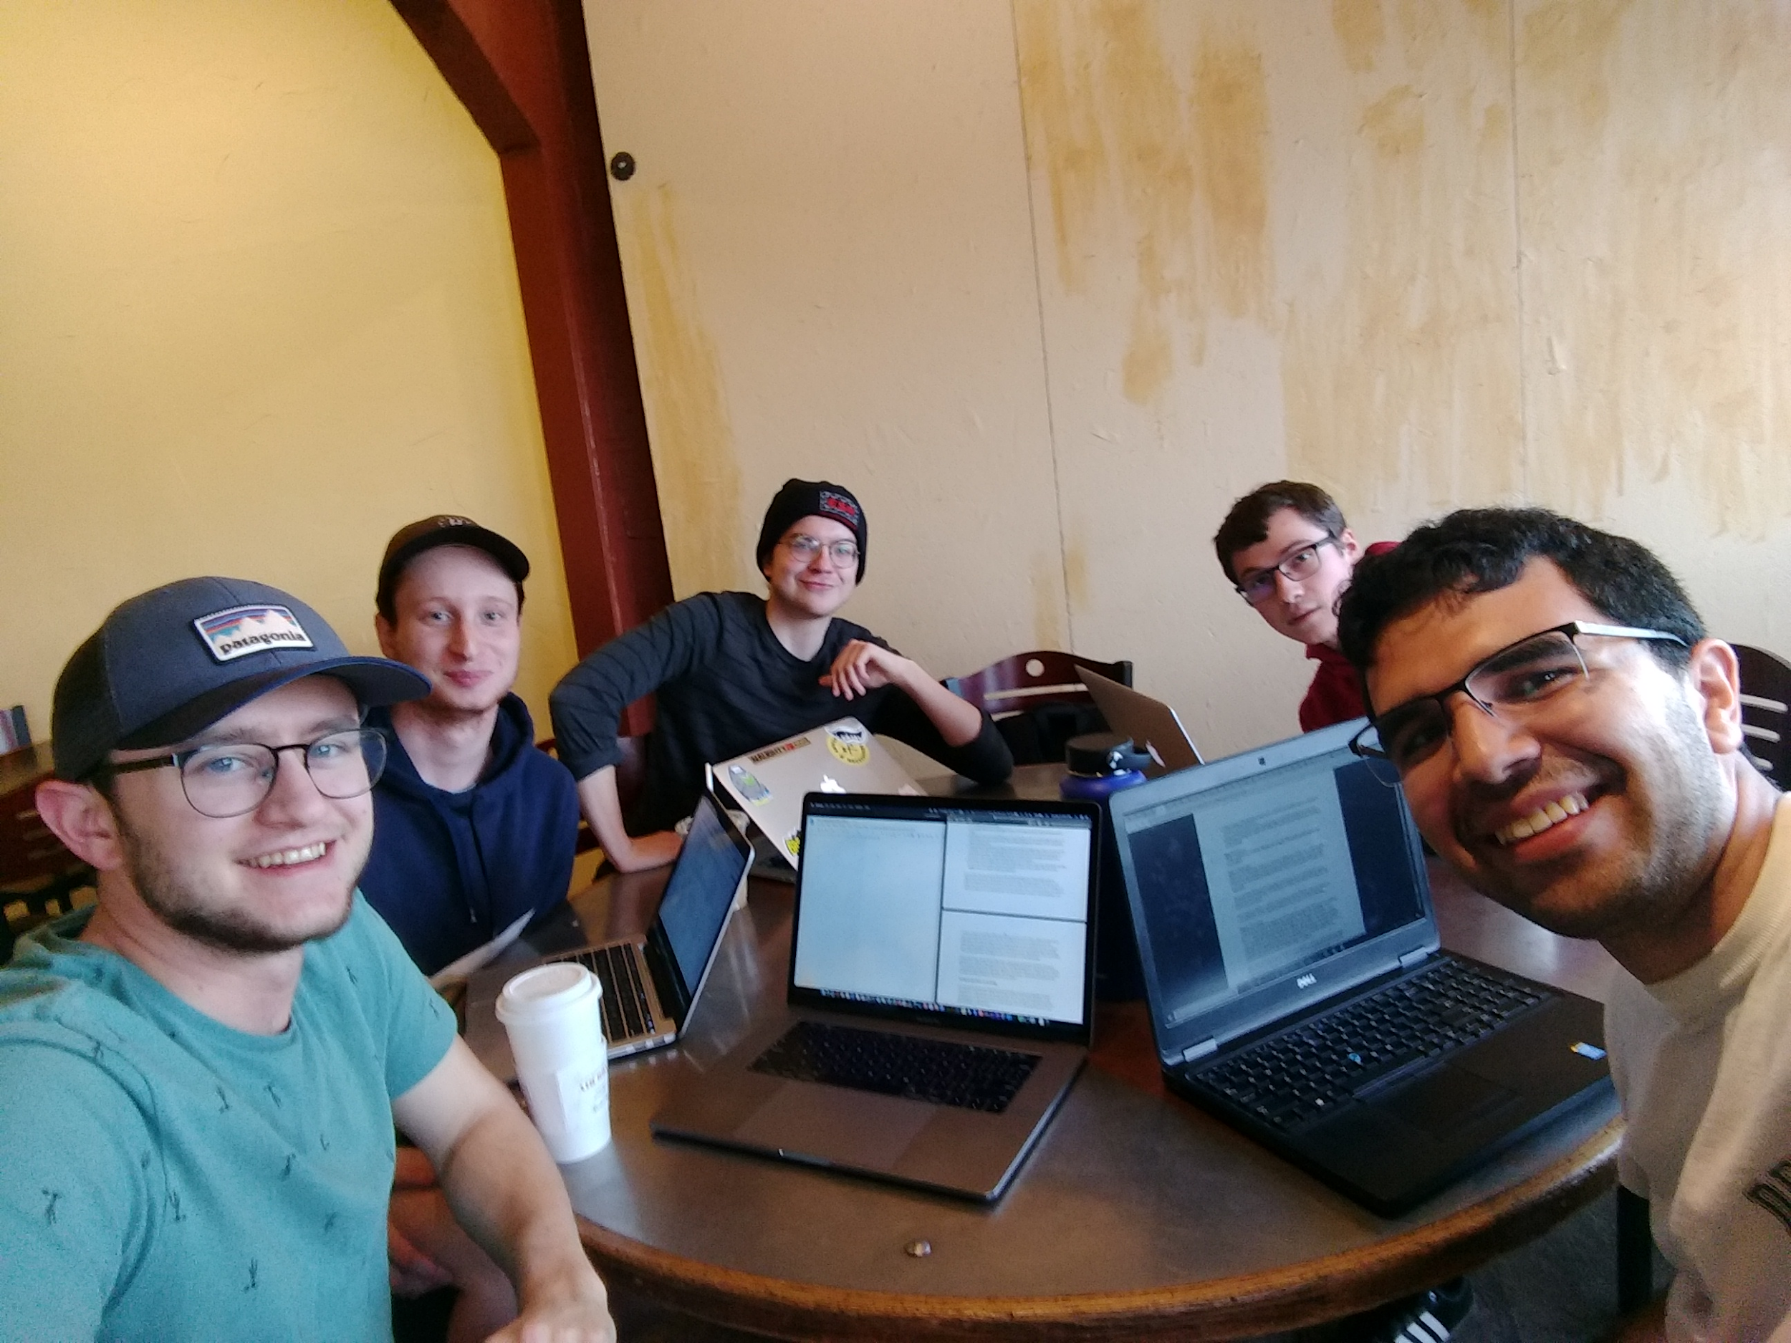

*CCR Takes on Kaladi’s*